Specialized Hardware:

Arithmetic Pipelining

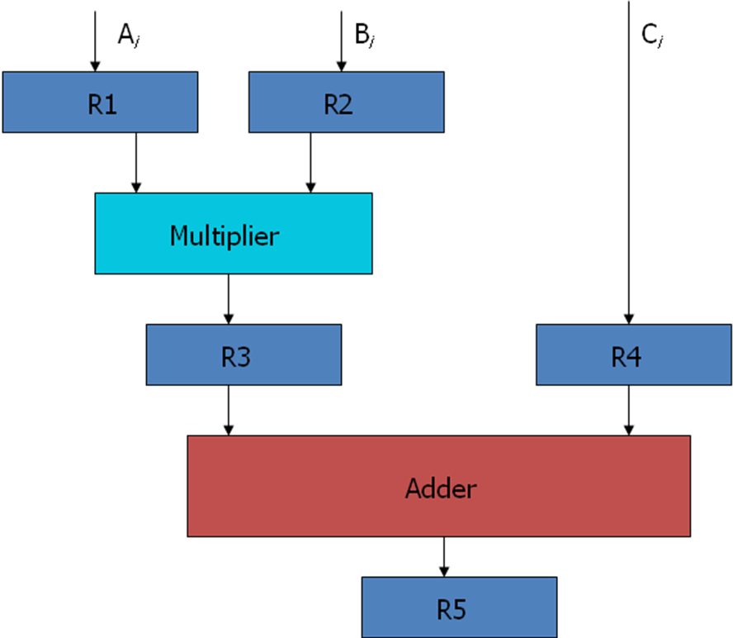
Fig 4-1: Example of pipeline processing

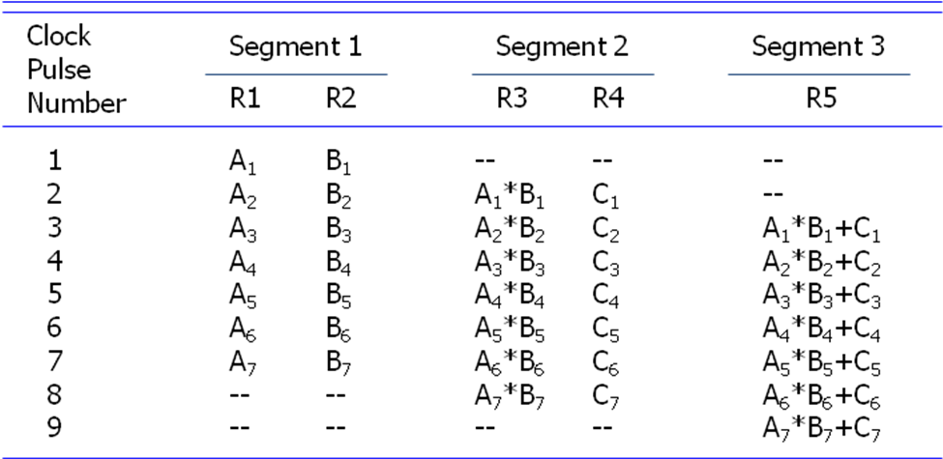

Table 4-1: Content of Registers in Pipeline Example

General Considerations (Speed up of a pipeline system)
Any operation that can be decomposed into a sequence of suboperations of about the same complexity can be implemented by a pipeline processor.
The general structure of a four-segment pipeline is illustrated in Fig. 4-2.
We define a task as the total operation performed going through all the segments in the pipeline.
The behaviour of a pipeline can be illustrated with a space-time diagram.
It shows the segment utilization as a function of time.
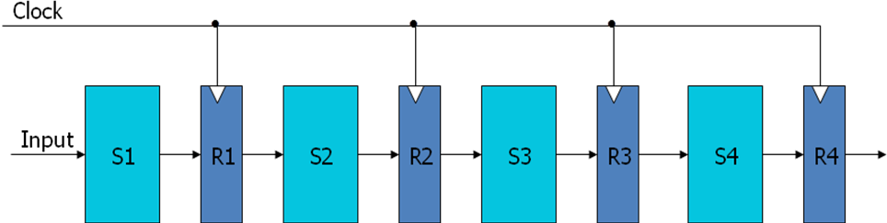
Fig 4-2: Four Segment Pipeline

The space-time diagram of a four-segment pipeline is demonstrated in Fig. 4-3.
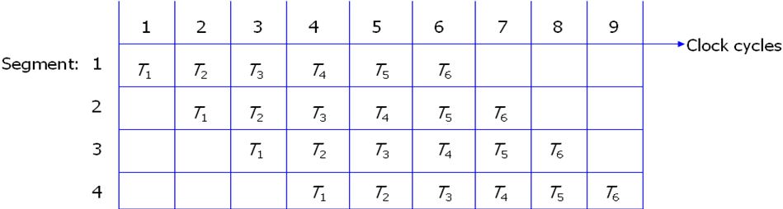
Fig 4-3: Space-time diagram for pipeline
Where a k-segment pipeline with a clock cycle time tp is used to execute n tasks.
Where, clock cycle time t_{p} is the time required to process a task in each segment.
For Pipeline
The first task T1 requires a time equal to kt_{p} to complete its operation.
The remaining n-1 tasks will be completed after a time equal to (n-1) t_{p}.
Therefore, to complete n tasks using a k-segment pipeline requires k+(n-1) clock cycles.
For Non-pipeline
Consider a non-pipelined unit that performs the same operation and takes a time equal to t_{n} to complete each task.
The total time required for n tasks is nt_{n}.

Speed up of a pipelining processing
The speedup of a pipeline processing over an equivalent non-pipeline processing is defined by the ratio S = nt_{n}/(k+n-1)tp .
If n becomes much larger than k-1, the speedup becomes, S = tn/tp.
If we assume that the time it takes to process a task is the same in the pipeline and non-pipeline circuits, i.e., t_{n} = kt_{p}, the speedup reduces to S=ktp/tp=k.
This shows that the theoretical maximum speed up that a pipeline can provide is k, where k is the number of segments in the pipeline. S_{max} = k.
To duplicate the theoretical speed advantage of a pipeline process by means of multiple functional units, it is necessary to construct k identical units that will be operating in parallel.

